DS 522 Data Acquisition and Analytics
HOS01A00 - Python and Visual Studio Installation
06/06/2024 Developed by Catherine Ata
03/01/2025 Reviewed by Yogesh Goel
03/18/2025 Reviewed by Naveena Moddu

School of Technology & Computing (STC) @City University of Seattle (CityU)
Before You Start.
- The directory path shown in screenshots may be different from yours.
- Some steps are not explained in the tutorial. If you are not sure what to do:
  - Consult the resources listed below.
  - If you cannot solve the problem after a few tries, ask a TA for help.

Learning Outcomes
Students will be able to:
- Setup the working environment for Python
- Installation of Python
- Installation of Visual Studio Code

Resources
- McKinney. (2022). Python for Data Analysis (3rd edition).
- Cotton. (2023). Tutorial: How to Install Python on macOS and Windows. https://www.datacamp.com/blog/how-to-install-python
- Phoenixnap.com. (2024). How to Install Python on Mac. https://phoenixnap.com/kb/install-python-mac
- Python.org. (2024). Python documentation. https://docs.python.org/3/
- Visualstudio.com. (2024). Setting up Visual Studio Code. https://code.visualstudio.com/docs/setup/setup-overview

Introduction

Visual Studio Code: Visual Studio Code, also commonly called VS Code, is a lightweight but powerful source code editor made by Microsoft with the Electron Framework which runs on your desktop and is available for Windows, macOS, and Linux. Features include support for debugging, syntax highlighting, intelligent code completion, snippets, code refactoring, and embedded Git.

Python: Python is a high-level, general-purpose programming language widely used for developing web applications and software due to its powerful syntax and dynamic typing.

Installing VS Code
- Visit https://code.visualstudio.com/Download
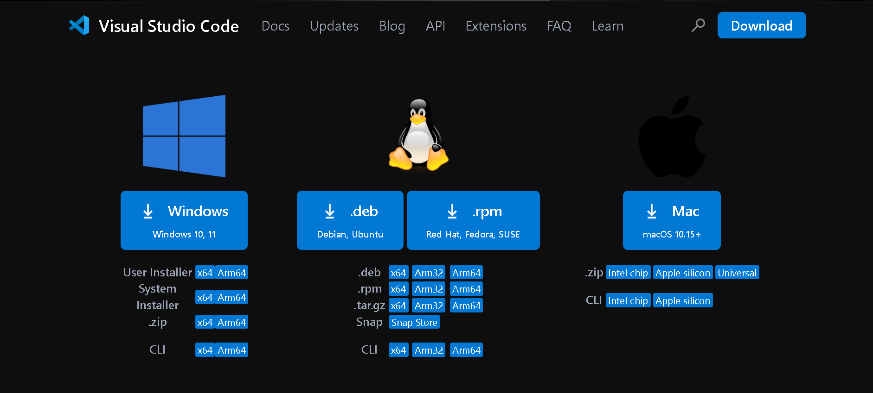

- Select the correct version for your operating system and download it.
For example, you can download “VSCodeUserSetup-x64-1.94.00” for Windows 11 or “VSCode-darwin-universal” for macOS.

- To install VS Code, accept agreement when prompted, keep the default tasks, and follow setup instructions.
NOTE: Make sure to select the Add to Path option to avoid having issues later.

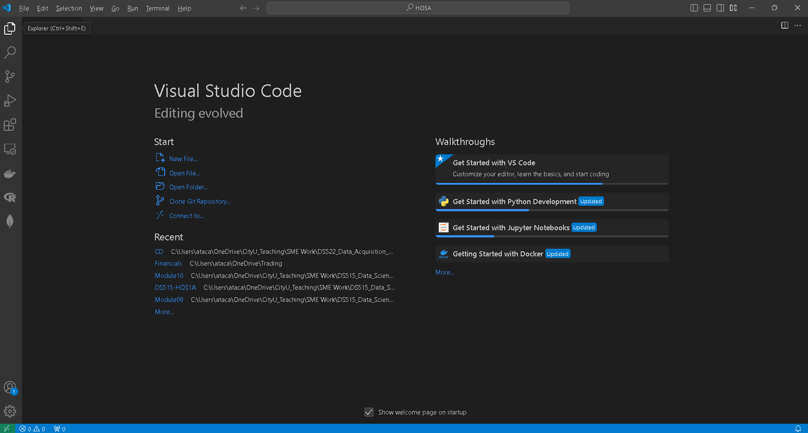
- After installing the VS Code, this will automatically launch VS Code.

Making your development directory

- On the menu tab, select File, then Open New Folder. Navigate to your work directory. For example: C:\Users\my_workspace\Desktop
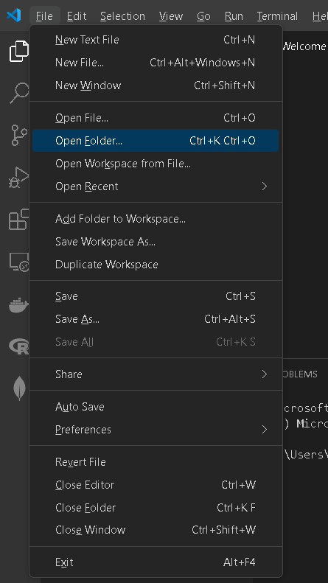

- Once in your work directory, go to the menu tab, select Terminal, select New Terminal to open a Command Line Interface (CLI) like the Command Prompt or PowerShell for Windows OS.
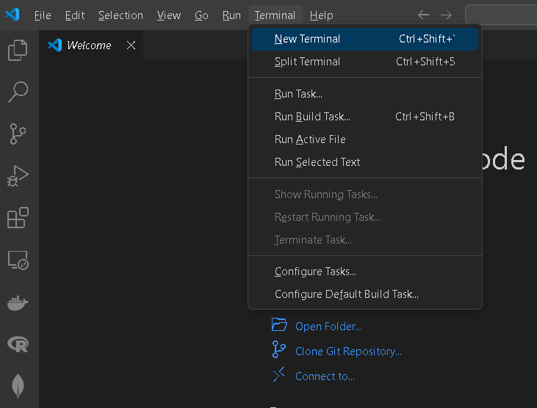

- Create a working directory called “DS522” for your course and move to the directory. Use the following commands.
>mkdir DS522
>cd DS522
>dir
References to create a directory:
For Windows:
https://www.digitalcitizen.life/command-prompt-how-use-basic-commands
https://www.thomas-krenn.com/en/wiki/Cmd_commands_under_Windows

For Mac:
https://setapp.com/how-to/make-folder-on-mac

Note: Remember the path to your DS522 directory, this will be your main working directory for the course.

- Clear your CLI by running the command below.
>>> cls
- Close the VS Code.

Install Python on your machine.
If you have already installed Python3, please skip this section. To check, open your terminal or command prompt and type the following command:
>python --version

This should show your Python version; for example, Python 3.12.00. If you do not have Python installed, you will get a “command not found python” message instead.

Proceed with the installation by following the instructions below:
- Click the following link to download the current version of Python https://www.python.org/downloads/

- Use the link for your operational system and make sure to select Stable version:

- Perform the installation process:

On Windows, download the Python installer (the filename will end with ARM) and click it. Follow the instructions provided to install Python:
- Select Install for All Users and then click Next.
- Install to the C:\Python folder by clicking Next.
- Click Next again to skip the Customize Python section.

On MacOS, download the universal2 installer and click the link. Follow the instructions provided to install Python:
- Use Finder to locate the PKG installer and run it. You may be asked to enter the administrator password.
- Click Continue when the Welcome window opens.

- Click Install to perform Standard installation, otherwise, click Customize then select the features/ components you want to include then click install.
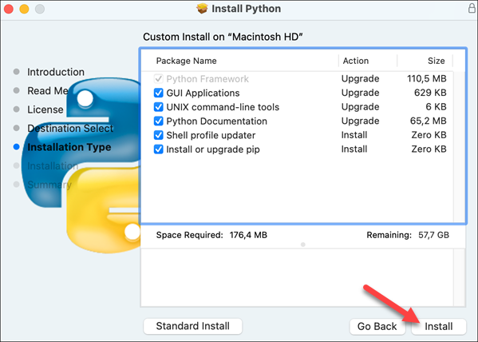

Wait for the installation to finish then Close the installer window.

- After the installation, open a terminal and type the following command to test it:
>>> python --version
Note: This should show the Python version you just installed.

- It is also recommended to install the Python extension in the VS Code.
Go to VS Code -> Click the View on the top menu -> Extensions in the VS Code menu.
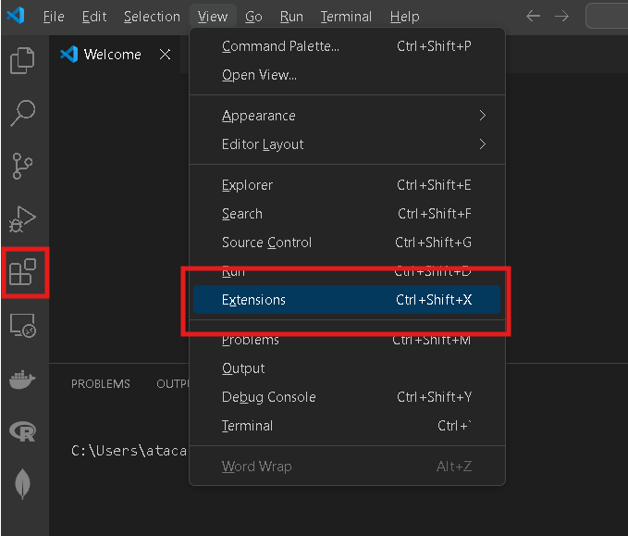

Search “Python” and click the Install button on the right -> click Install button.

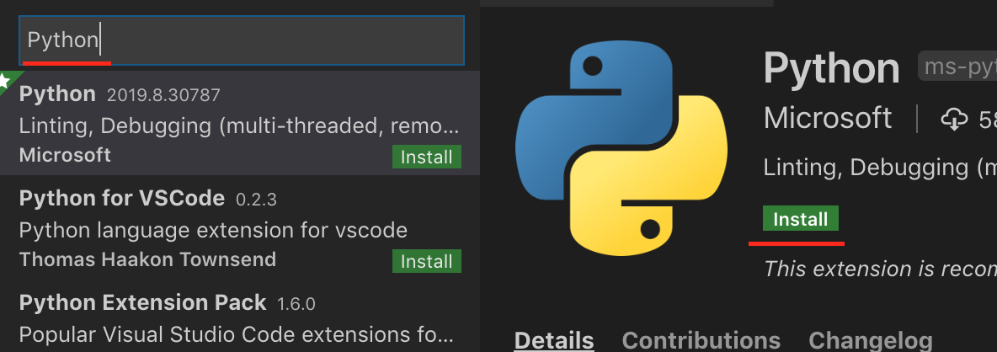

NOTE: The Python version you have installed may be different from the ones shown in the examples.

PLEASE PROCEED WITH THE HOS01A ASSIGNMENT.

